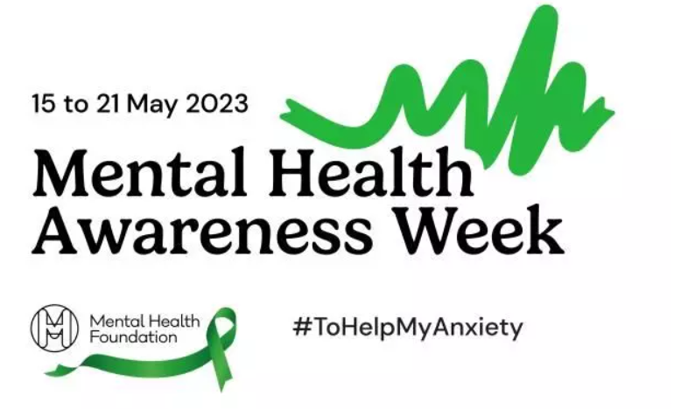
This week in school, we have been talking about Mental Health Awareness Week and thinking about how to help our own Mental Health and also look after others.
We have completed fun activities, worked on friendships and practised mindfulness breathing.

We are always looking for ways to support our families. Here are a few useful websites and resources you could use to support your mental health, as well as your children’s.
Mental Health Foundation
This website has lots of information about Mental Health Awareness Week and helpful information around understanding and coping with anxiety.
https://www.mentalhealth.org.uk/
NHS Mind Plan Quiz
Answer 5 simple questions to get your personalised mental health action plan with tips and advice to help you be kind to your mind.
https://www.nhs.uk/every-mind-matters/mental-wellbeing-tips/your-mind-plan-quiz/
Place2Be – Parent Smart
This website has lots of short videos with practical tips to support children’s wellbeing and behaviour. Videos cover topics such as ‘Helping your child prepare for high school’, ‘Co-parenting’, ‘Supporting healthy gaming habits’, ‘Promoting positive body image,’ and lots more.
https://parentingsmart.place2be.org.uk/
Money Advice
Martin Lewis’ website offers lots of advice around Mental Health and money. There is also a new free booklet to download called ‘Mental Health and Debt.’
https://www.moneysavingexpert.com/credit-cards/mental-health-guide/
CAMHS virtual training
Members of the Liverpool CAMHS Partnership design and deliver an ongoing programme of training opportunities for professionals as well as parents and carers. Visit their website to book onto any of their upcoming courses.
https://www.liverpoolcamhs.com/professionals/training/
Please get in touch if you would like any additional information or support from school around Mental Health.

